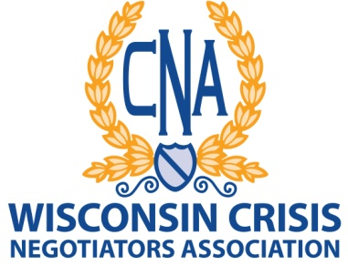

ANNUAL AWARDS NOMINATION APPLICATION

DATE:_________________________

NOMINEE:____________________________________DEPARTMENT:_________________________________

Nominating
Member:______________________________________Department:___________________________________

Nominated for: Please check one:
__ Crisis Negotiator of the Year __ Medal of Honor Award
__ Meritorious Service Award __ Distinguished Service Award
__ Public Service Award ___ Memorial Award

Describe the event(s) and/or reason(s) that you have nominated the above named member(s). Please be as specific as possible. Attach reports, newspaper articles or other documentation that will assist the Awards Committee and the Board of Directors in determining what awards should be approved and awarded.

Email to: Denise Nash, President

nashd@co.portage.wi.us ________________________________________________________
Signature of Person making nomination

